Draft Joint LDAC-MAC Advice v3
Urgent need for effective implementation of EU import control rules across Member States
Madrid/Brussels, 26 May 2025

Background
The new Commissioner for Fisheries and Oceans, Dr. Costas Kadis, has been entrusted by President von der Leyen to “take action to uphold a level playing field and protect the European fisheries chain from unfair global competition, notably on seafood products”, as well as “ensuring that Europe retains its international leadership with its zero tolerance approach to illegal, unreported and unregulated fishing” .
Considering that the European Union is a top importer of seafood globally, with an import value of USD 33.2 billion in 2022 (approx. EUR 32 billion), ensuring that foreign products tainted by IUU fishing and associated abuses, such as the use of forced labour aboard fishing vessels, cannot enter the EU market is essential to safeguard marine ecosystems, the food security of coastal communities around the world, and to uphold decent working conditions. With the EU importing over 60% of its seafood, import controls are also critical to protect the EU's fishing fleet competitiveness by ensuring fair competition for legal EU-registered fishing vessels. However, there is some suspicion that products of fleets associated with IUU fishing could be entering the EU market, including products from China and Russia—two of the flag states that are considered to be of highest risk for IUU fishing.
For the EU to deliver its ambition, it will be essential for it to tighten seafood import controls to ensure that they do not come from IUU fishing
In 2022, a European Court of Auditor (ECA) special report highlighted that the significant differences in scope and quality of checks by Member States are weakening the whole EU import control system. In 2023, joint advice by the Long Distance Advisory Council (LDAC) and the Market Advisory Council (MAC) echoed the ECA findings. It provided further details on weaknesses in implementation and the lack of harmonisation and intensity of import controls across the EU. This joint advice was built on an analysis of the 2018-2019 biennial reports on the implementation of the Council Regulation (EC) No. 1005/2008 (the IUU Regulation) by several members of the LDAC and the MAC, under the umbrella of the EU IUU Fishing Coalition.
In its report, the ECA made a recommendation to the European Commission to “monitor that the scope and quality of checks by Member States are sufficient to address the risks and take necessary actions to remedy any shortcomings” by 2026. This recommendation was accepted by the European Commission, who sought to address it in part by revising the EU's fisheries control rules and mandating the adoption of a digital catch certification scheme. However, based on the latest data on the implementation of import controls by Member States, the [LDAC and the MAC] still doubt that the adoption of such a digital scheme will fully resolve the issues highlighted by the ECA and by the LDAC and MAC in their 2023 joint advice.
As such, the [LDAC and the MAC] consider that the ECA recommendation to “take necessary actions to remedy any shortcomings” in the scope and quality of checks by Member States remains relevant.
The present advice provides recommendations to the European Commission and Member States based on an updated state of play of the implementation of import control rules since 2019. The analysis is based on the data extracted from the 2020-2021 and 2022-2023 Member States biennial reports on the implementation of the IUU Regulation, and focuses primarily on the verification of catch certificates, the physical inspections conducted and the rejection of suspicious imports. The present analysis builds on a preliminary analysis which was presented by the members of the EU IUU Fishing Coalition to the LDAC in October 2024 and to the MAC in March 2025.

- Recommendations
The [LDAC and the MAC] acknowledge that “the EU has strict controls to ensure imported food meets high standards for consumer protection and safety” and agrees on the importance of “improving the level playing field with third countries on aspects of social and environmental sustainability”. Regarding import control, although the legal framework for strict control is in place, the [LDAC and the MAC] note that its implementation is still not robust or harmonised. This leaves the EU vulnerable to “control shopping”, whereby products tainted with IUU fishing could be preferentially imported through Member States implementing insufficient controls, thereby undermining the efforts of more demanding Member States and putting law-abiding EU operators at risk and exposing EU consumers to seafood potentially tainted with illegality.
The [LDAC and the MAC] note the European Commission’s focus “on the gradual but timely and full implementation of the revised fisheries control system, and on the roll-out of the digital IUU catch certification scheme as a tool to protect our market, our consumers and fishers against imports of IUU fish from third countries”, but reiterates that the results of the full digitalisation of catch certificates from January 2026 onward will need to be monitored to check its efficiency, while further action from the Member States are and will be required to improve import controls.
In view of the European Commission’s renewed zero-tolerance ambition towards IUU fishing and its commitment to uphold a level playing field and protect the EU fisheries from unfair global competition, the [LDAC and the MAC] would like to reiterate some of the recommendations already laid out in the 2023 joint LDAC-MAC advice, which we believe should be prioritised in view of the results of the analysis of the 2020-2023 biennial reports.
The European Commission should:
- Allocate sufficient human resources and financial means to the Directorate-General for Maritime Affairs and Fisheries of the European Commission for carrying out monitoring, control and surveillance activities linked to IUU fishing—increasing the number of officials with knowledge and ability to perform regular audits and be present in third countries through recurrent missions, to ensure the effective implementation of the measures.
- Leverage the digitalisation of the catch certification system and make full use of the resulting database to enable advanced analysis – where applicable, supported by tools such as artificial intelligence – and to facilitate cooperation between Member States and the European Commission to target better and coordinate controls.
- In parallel with the deployment of the CATCH IT system, prioritise launching infringement procedures against Member States that fail to implement the import control rules embedded in the EU IUU Regulation
- Provide, together with the European Fisheries Control Agency, adequate intelligence and support to Member States to improve the effectiveness of control systems for preventing the import of IUU fishery products. This should include proactively use of the Mutual Assistance System and sharing detailed information on shortcomings identified in the context of the implementation of the EU IUU Regulation with regard to non-EU countries.
- Encourage Member States to improve data submission in biennial reports and collaborate on a solution for public access, keeping information confidential only when strictly necessary. Making these reports more accessible is essential for the economic sector (e.g., retailers, traders, processors, and EU fishing companies) and civil society to apprehend the IUU fishing risks in the global supply chains. It also strengthens the role of advisory councils like the [LDAC and the MAC] in providing informed recommendations to the Commission and Member States.
- Beyond import controls, make full use of the legal instruments available under the EU IUU Regulation to ensure that products stemming from flagrant illegal activities cannot access the EU market. In that context, and where appropriate, consider whether stock- or species-specific prohibitions (as foreseen under Article 38(1)) could serve as an effective tool to combat IUU fishing and uphold a level playing field.

- Beyond import controls, make full use of the legal instruments available under the EU IUU Regulation to ensure that products stemming from flagrant illegal activities cannot access the EU market. In that context, and where appropriate, consider whether stock- or species-specific prohibitions (as foreseen under Article 38(1)) could serve as an effective tool to combat IUU fishing and uphold a level playing field.
Member States should:
- Allocate sufficient capacity and resources to ensure effective implementation of IUU import controls under the IUU Regulation
- Implement thorough verification and inspection procedures for higher risk catch certificates, consignments and direct landings, and ensure that importations of fishery products obtained from IUU fishing are refused in line with Article 18 of the IUU Regulation.
- Ensure complete and accurate responses to all Commission questions in biennial reports and make them publicly available, keeping information confidential only when strictly necessary. Certain data should always be disclosed, including: the numbers of catch certificates received and accepted; the number of processing statements received and accepted, with details by flag State of origin and associated catch certificates; the number of verification requests sent to each flag, processing, or other state; the number of rejections per flag state; the number of direct landings and the number of inspections carried out on direct landings, by flag State.

ANNEX – ARGUMENTS

Results of the analysis of the data from the biennial reports on the implementation of the IUU Regulation

Preliminary remarks on the method and field of investigation:
- The present analysis excluded Luxembourg for 2020-2023 as they did not report to the European Commission despite the existing legal requirement.
- For the 2022-2023 period, data from France and Finland was excluded, as France refused to provide access to their biennial reports to the EU IUU Fishing Coalition, and data on the imports rejected during this period for Finland was not available to the EU IUU Fishing Coalition. The [LDAC and the MAC] reiterate their 2023 recommendation for the European Commission and Member States to make the biennial reports under the IUU Regulation publicly available.
Main results of the analysis:
- Low verification and rejection rates of imported fishery products persist across the EU, including for imports from countries at high risk of IUU fishing
- Some top importing Member States are reporting particularly low verification and rejection rates of imported fishery products
- Non-compliance with the 5% legal threshold for physical inspection of “direct landings” persists
- Low verifications and rejections of imported fishery products persist across the EU, including in relation to imports from countries with a high risk of IUU fishing
Across the EU, only a small number of catch certificates received from third countries were subject to verification requests to the flag state or resulted in imports being rejected. Between 2020 and 2023, of the 794,336 catch certificates received from third countries, only 0.29% were verified with the flag states, and 0.01% were rejected (Figure 1).
Figure 1: Low verification and rejection rates of imported fishery products persist across the EU in 2020-2023
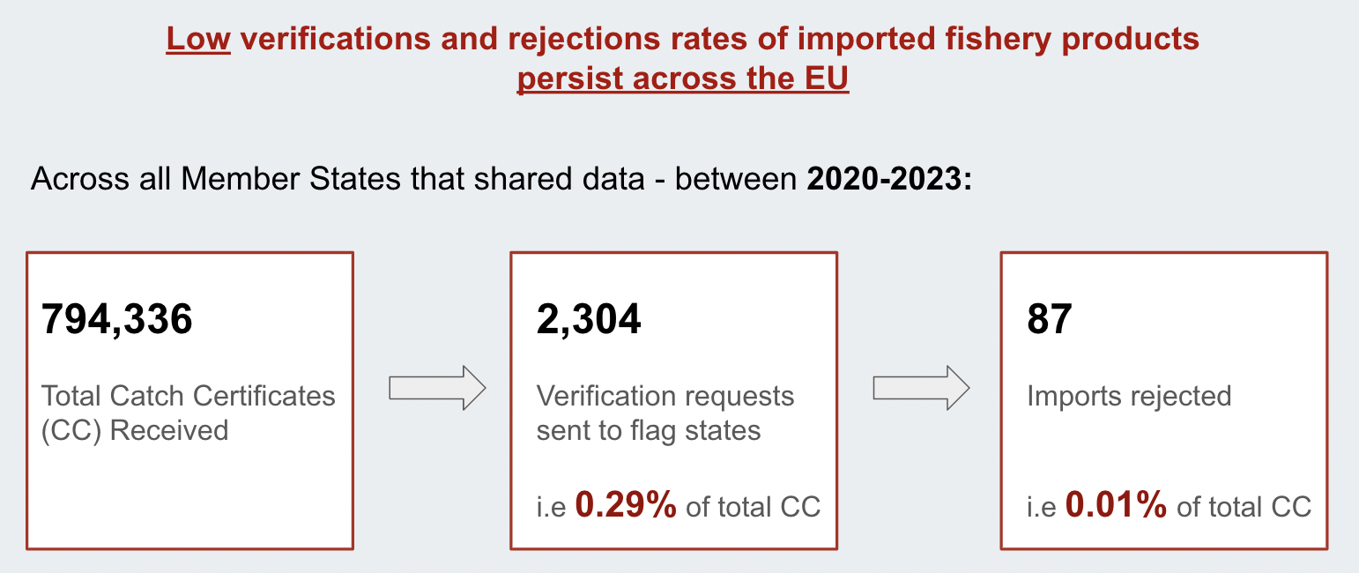
For imports from Chinese-flagged vessels specifically, verification requests and imports rejected were close to nil across the EU between 2020 and 2023 (Figure 2). In 2020-2021, across 26 reporting Member States, only 0.3% of the 14,653 catch certificates received from China were subject to flag state verification requests, and zero imports originating from that flag state were rejected under the IUU Regulation. In 2022-2023, across the 24 Member States that disclosed data, only 0.4% of the 13,697 catch certificates received from China led to verification requests, and only 2 imports were rejected. These numbers raise questions when considering the increasing instances of systemic IUU fishing associated with the Chinese fleet documented by the NGOs EJF and The Outlaw Ocean Project,,. It is recalled that in December 2022, the LDAC and the MAC adopted a joint advice on the implications for fisheries governance of China’s global distant water fleet activities.
Figure 2: Catch certificates for fisheries products from China are still weakly verified and rejected in 2020-2023
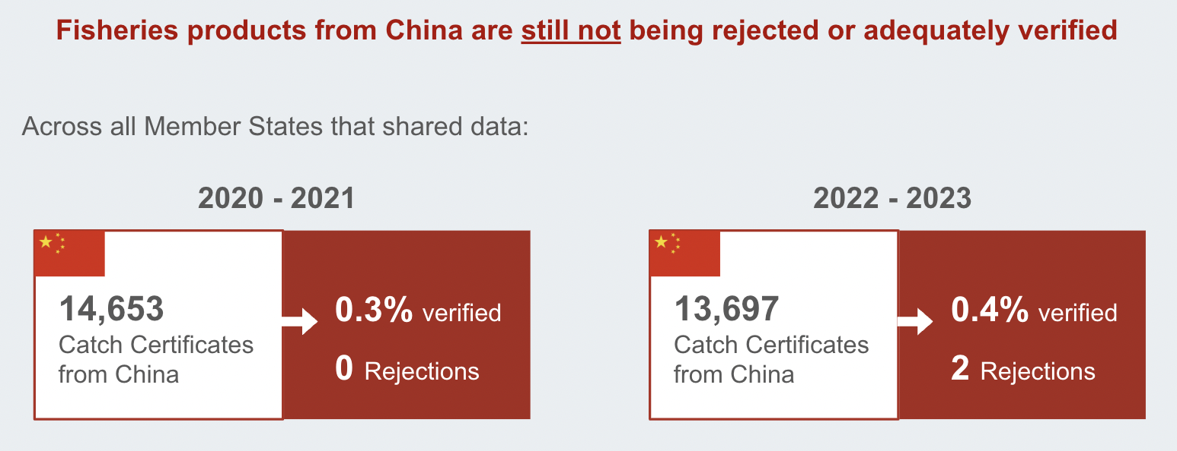
In addition, most Member States report not conducting verifications with states other than the flag states (i.e., processing states, storage states, etc.) or do not provide such information. For instance, between 2020 and 2023, Spain sent 215 requests to states other than flag states, whereas other large importing countries like Italy and Portugal did not report sending any. If that trend is confirmed, it further suggests a lack of thorough verification of catch certificates and is particularly concerning given that about 30% of all processing statements received across the EU come from China, a country where some seafood processing plants are suspected to be linked to illegal activities. It is also noted that some Member States (e.g., Italy) do not provide the required information on the number and origin of the processing statements received.

Some top importing Member States are reporting particularly low numbers of verifications and rejections of catch certificates of imported fishery products
A large number of consignments, including from high-IUU risk flag states such as China and “yellow carded” countries (i.e., countries pre-identified by the European Commission as not cooperative in the fight against IUU fishing), are entering the EU through top importing Member States that perform limited to nil verifications of catch certificates or refuse imports. Figure 3 shows the difference between Member States such as Portugal, Italy and Sweden, which hardly ever check or reject imports (see relevant lines in red in the table), and other major importers like Spain, who perform hundreds of verifications and reject dozens of imports yearly. This data is particularly concerning for Italy and Portugal, given that a relatively high proportion of the catch certificates received by these countries come from high IUU-risk flag states. Even the most active Member States in import controls, verifications and rejections remained low from 2020 to 2023 compared to the total number of catch certificates they received. These indicators raise concerns given that the EU IUU import control system is only as strong as its weakest link. Robust and harmonised import controls must be implemented across the EU.
Figure 3: Verifications and rejections rates of catch certificates for imported fishery products by some top importing Member States
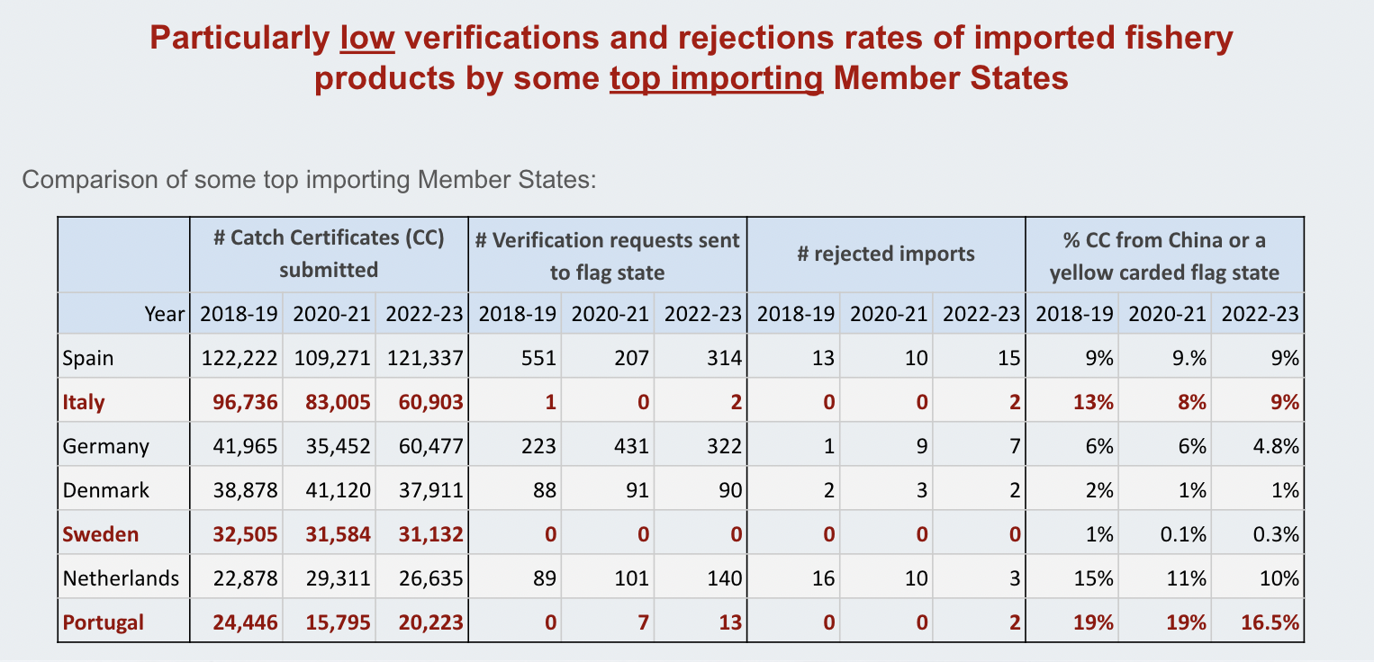
This figure shows data from top importing Member States, including 2018–2019, to highlight changes over time.

Non-compliance with the 5% legal threshold for physical inspection of direct landings persists
Member States are legally required to inspect at least 5% (on average across all flag states of origin) of landing and transhipment operations (“direct landings”) by third country fishing vessels in their ports. Non-compliance with this legal threshold (see rows in red in Figure 4) had already been observed in 2018-2019 and persisted in 2020-2023 in the Netherlands, Denmark and Poland. There is a striking difference between these Member States and others, like Spain, which took delivery of similar amounts of direct landings but inspected over 80% of these landings on average over this period.
Figure 4: Non-compliance with the 5% minimum physical inspection of direct landings persists in several Member States
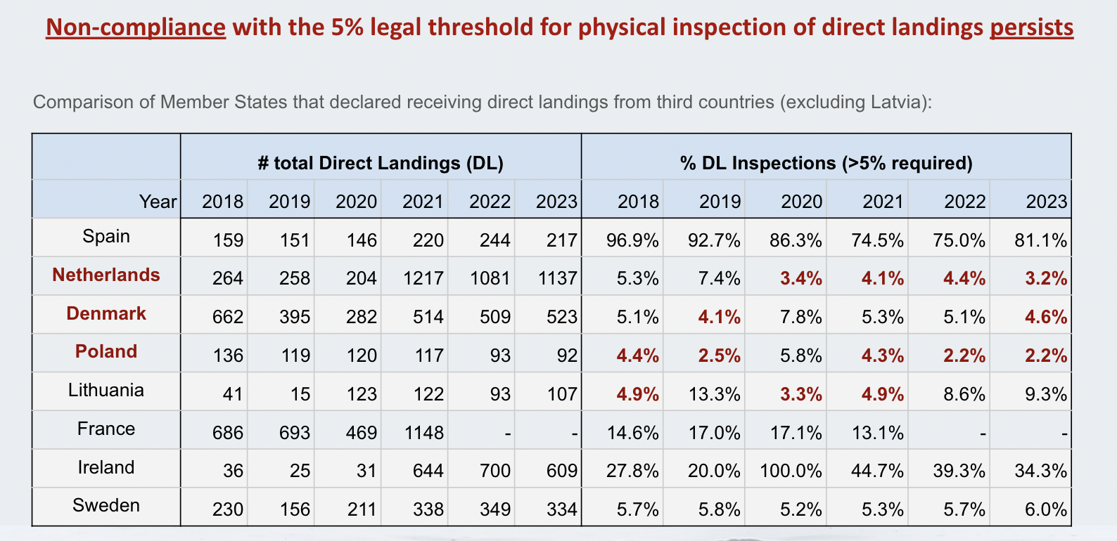
This figure includes all Member States that reported direct landings from third countries, except Latvia due to low numbers. It also includes 2018–2019 data to show changes over time. France's 2022–2023 data is missing because this Member State declined to share its report.
Port State measures are widely recognised as a powerful and cost-effective tool for combating IUU fishing. Therefore, the persistent failure to meet the minimum inspection rate requirement of at least 5% as stipulated in the IUU Regulation is concerning. This concern arises when analysing the average inspection rates of Member States taking delivery of direct landings, given that the Russian fleet is considered to be at high-risk of IUU fishing–with Russia, for instance, ranking as the second-highest IUU-risk flag state globally according to the IUU Fishing Risk Index, and having been at the centre of compliance concerns in regional fisheries management organisations,. Between 2020 and 2023, 86% of all Russian direct landings into Europe were in the Netherlands. This Member State reports not having complied with the 5% required inspection rate during this period (Figure 5). Despite the Netherlands' recent ban on Russia-flagged refrigerated ships, Russian catch still finds its way to the EU market by being transferred to Norwegian-flagged vessels, allowing it to enter Dutch ports with minimal inspection. By comparison, Spain, which took delivery of 12.8% of all Russian direct landings, inspected, on average, 78.5% of all direct landings over this period (Figure 5). If we examine the inspection rate of Spain and the Netherlands for Russian landings specifically (as opposed to the average across all flag states of origin, which is where the 5% mandatory threshold applies), the difference is again stark. For example, the Netherlands inspected only 6% of all Russian direct landings in the 2022-2023 period, whereas Spain inspected 100% of these landings.
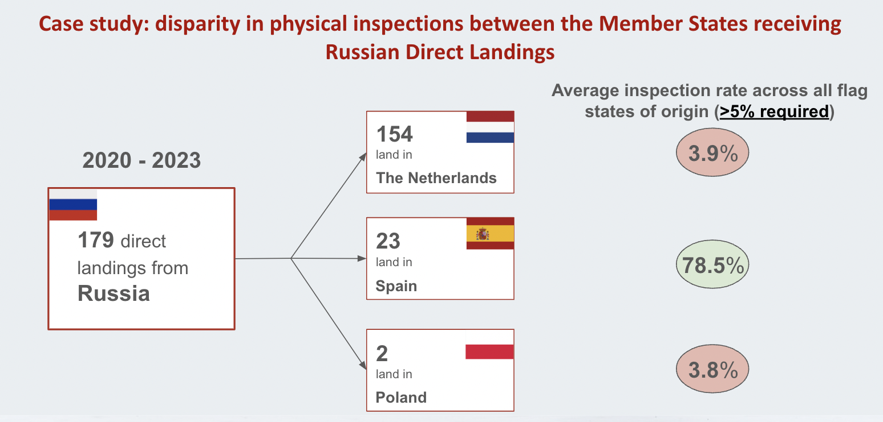
Figure 5: Disparity in physical inspections of direct landings

Mission letter to Costas Kadis, available at: https://commission.europa.eu/document/028ce7d5-e328-4416-8f0d-35c8884acaa8_en
FAO (2024), State of the World Fisheries and Aquaculture, available at: https://openknowledge.fao.org/items/06690fd0-d133-424c-9673-1849e414543d
FAO (2024), State of the World Fisheries and Aquaculture, available at: https://openknowledge.fao.org/items/06690fd0-d133-424c-9673-1849e414543d
Environmental Justice Foundation (2024), Tide of injustice - exploitation and illegal fishing on Chinese vessels in the Southwest Indian Ocean, available at: https://ejfoundation.org/reports/tide-of-injustice-exploitation-and-illegal-fishing-on-chinese-vessels-in-the-southwest-indian-ocean
De Groene Amsterdammer, 27 November 2024, Smuggling for Putin, available at: https://www.groene.nl/artikel/smokkelen-voor-poetin
China and Russia are the two countries considered to be of highest risk of IUU fishing according to the IUU Fishing Risk Index. This index was developed by Poseidon Aquatic Resource Management Ltd., a fisheries and aquaculture consultancy company, and the Global Initiative Against Transnational Organized Crime, a Geneva-based NGO network of experts working on human rights, democracy, governance, and development issues where organized crime has become increasingly pertinent. The index is available at: https://iuufishingindex.net/
European Court of Auditors. (2022). Special report 20/2022: EU action to combat illegal fishing – Control systems in place but weakened by uneven checks and sanctions by Member States. Available at: https://www.eca.europa.eu/en/Pages/DocItem.aspx?did=61941
MAC/LDAC (2023), The need for harmonised import controls between Member States in order to prevent the products of illegal, unreported and unregulated (IUU) fishing from entering the European Union market, available at: https://ldac.eu/images/MAC_LDAC_Advice_-_IUU_Import_Controls_21.04.2023.pdf
EJF, Oceana, The Nature Conservancy, The Pew Charitable Trusts and WWF. (2022). Water-tight? Assessing the effectiveness of EU controls to prevent illegal seafood imports. Available at: https://www.iuuwatch.eu/2022/11/blog-eu-member-state-import-controls-insufficient-to-block-illegallysourced-seafood-from-entering-the-market/
European Commission (2022), Replies of the European Commission to the European Court of Auditors’ special report: EU action to combat illegal fishing - Control systems in place but weakened by uneven checks and sanctions by Member States, available at: https://www.eca.europa.eu/Lists/ECAReplies/COM-Replies-SR-22-20/COM-Replies_SR-22-20_EN.pdf
EJF, Oceana, The Nature Conservancy, The Pew Charitable Trusts and WWF. (2022). Water-tight? Assessing the effectiveness of EU controls to prevent illegal seafood imports. Available at: https://www.iuuwatch.eu/2022/11/blog-eu-member-state-import-controls-insufficient-to-block-illegallysourced-seafood-from-entering-the-market/
The 2020-2021 and 2022-2023 biennial reports were obtained by the EU IUU Fishing Coalition via access for information request to the European Commission. The biennial reports obtained are available here: https://www.iuuwatch.eu/the-iuu-regulation/member-state-implementation/. The data was not accessible for Luxembourg given this Member State did not send biennial reports to the European Commission in 2020-2023, and the 2022-2023 data for France was not accessible given France refused to share its latest biennial reports with the EU IUU Fishing Coalition. The 2022-2023 data for Finland was also excluded from this analysis because Finland’s data on the imports rejected during this period was not available to the EU IUU Fishing Coalition, but Finland reported having received a total of 2,678 catch certificates in 2022-2023 (including 3 from China), and 12 of these catch certificates (i.e., 0.45 %) led to a verification request being sent to the flag state (with 0 verification request sent to China).
This presentation of a preliminary analysis by the Environmental Justice Foundation, a member of the EU IUU Fishing Coalition, is available at: https://www.ldac.eu/images/EU_IUU_Fishing_Coalition_presentation_16_10_24-preliminary_analysis_import_control_implem_Amelie_Giardini.pdf
MAC (2025) Working Group 2, 27 March 2025, https://marketac.eu/events/working-group-2-13/
European Union (2024), Questionnaire to the Commissioner-designate Costas Kadis Fisheries and Oceans, available at: https://hearings.elections.europa.eu/documents/kadis/kadis_writtenquestionsandanswers_en.pdf
MAC/LDAC (2023), The need for harmonised import controls between Member States in order to prevent the products of illegal, unreported and unregulated (IUU) fishing from entering the European Union market, available at: https://ldac.eu/images/MAC_LDAC_Advice_-_IUU_Import_Controls_21.04.2023.pdf
The terminology “direct landings” should be understood as operations falling within the scope of Article 9 of the IUU Regulation: “Member States shall carry out inspections in their designated ports of at least 5 % of landing and transhipment operations by third country fishing vessels each year”.
Verifications take place in accordance with Article 17 of the IUU Regulation.
Environmental Justice Foundation (2022), The ever-widening net: Mapping the scale, nature and corporate structures of illegal, unreported and unregulated fishing by the Chinese distant-water fleet, available at: https://ejfoundation.org/resources/downloads/The-Ever-Widening-Net-2022-final.pdf
Environmental Justice Foundation (2024), Tide of injustice - exploitation and illegal fishing on Chinese vessels in the Southwest Indian Ocean, available at: https://ejfoundation.org/reports/tide-of-injustice-exploitation-and-illegal-fishing-on-chinese-vessels-in-the-southwest-indian-ocean
The Outlaw Ocean Project (2023 & 2024), China: the superpower of seafood, available at: https://www.theoutlawocean.com/investigations/china-the-superpower-of-seafood/
LDAC/MAC (2022), Addressing China’s global distant water fleet activities implications for fisheries governance, available at: https://ldac.eu/images/LDAC-MAC_Joint_Advice_China_Distant_Water_Fleets_13Dic2022.pdf
The New Yorker, 9 October 2023, The Uyghurs Forced to Process the World’s Fish, available at: https://cdn.theoutlawocean.com/investigations/china/pdf/publications/the-new-yorker--the-uyghurs-forced-to-process-the-worlds-fish.pdf
Council Regulation (EC) No 1005/2008 of 29 September 2008 establishing a Community system to prevent, deter and eliminate illegal, unreported and unregulated fishing, https://eur-lex.europa.eu/legal-content/EN/TXT/?uri=CELEX%3A02008R1005-20240109
EJF, Oceana, The Nature Conservancy, The Pew Charitable Trusts and WWF. (2022). Water-tight? Assessing the effectiveness of EU controls to prevent illegal seafood imports. Available at: https://www.iuuwatch.eu/2022/11/blog-eu-member-state-import-controls-insufficient-to-block-illegallysourced-seafood-from-entering-the-market/
See footnote 6.
Dialogue Earth, 12 January 2021, “Controversy over Russian vessel in Antarctica reveals CCAMLR shortcomings”. Available at: https://dialogue.earth/en/ocean/15935-controversy-over-russian-vessel-in-antarctica-reveals-ccamlr-shortcomings/
European Commission, 21 November 2024, “North-East Atlantic fisheries face significant challenges in conservation and control, as unprecedented disagreements emerge”. Available at: https://oceans-and-fisheries.ec.europa.eu/news/north-east-atlantic-fisheries-face-significant-challenges-conservation-and-control-unprecedented-2024-11-21_en
The Barent Observer, 28 November 2024, “Fishing for Putin”. Available at: https://www.thebarentsobserver.com/news/fishing-for-putin/

